1.EXECUTIVE OVERVIEW

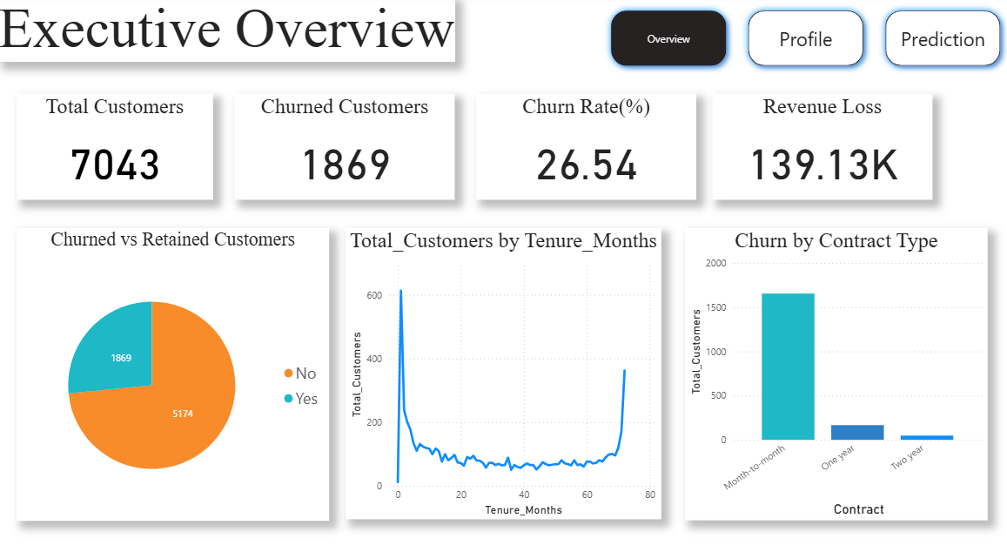
2.CUSTOMER PROFILE ANALYSIS
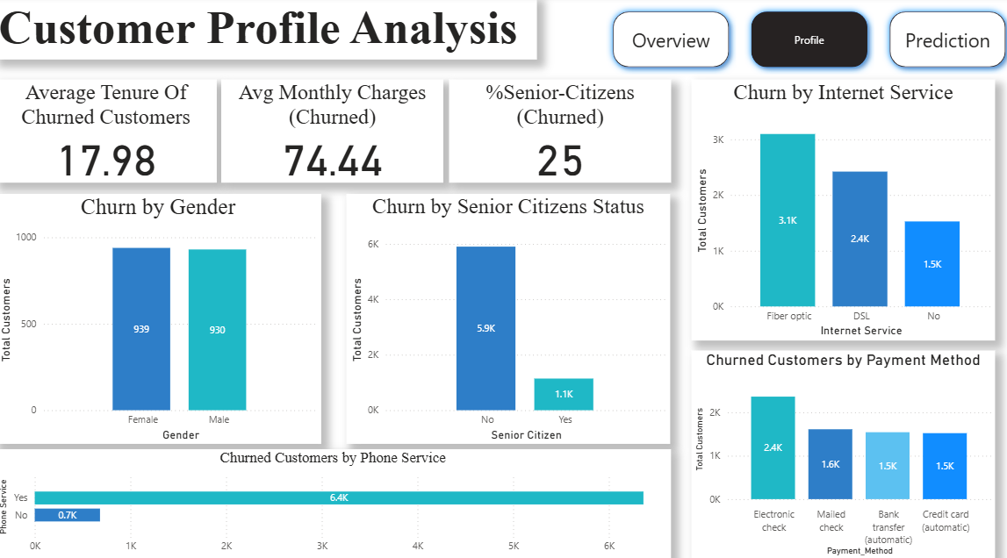

3. PREDICTION & ACTION
